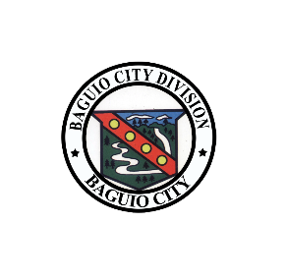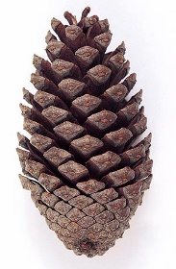

**BAGUIO –** Feb. 06-10, 2016

**BAGUIO –** Feb. 06-10, 2016

**BAGUIO –** Feb. 06-10, 2016

**A T H L E T E**

**CARAA 2016**

Republic of the Philippines  
**Department of Education**Cordillera Administrative Region  
Division of Baguio City

**BAGUIO –** Feb. 06-10, 2016

**C O A C H**

Republic of the Philippines  
**Department of Education**Cordillera Administrative Region  
Division of Baguio City

**CARAA 2016**

**FRANCIS CESAR B. BRINGAS, CESO VI**Schools Division Superintendent

**FRANCIS CESAR B. BRINGAS, CESO VI**Schools Division Superintendent

**FRANCIS CESAR B. BRINGAS, CESO VI**Schools Division Superintendent

**FRANCIS CESAR B. BRINGAS, CESO VI**Schools Division Superintendent

**CARAA 2016**

Republic of the Philippines  
**Department of Education**Cordillera Administrative Region  
Division of Baguio City

Republic of the Philippines  
**Department of Education**Cordillera Administrative Region  
Division of Baguio City

**CARAA 2016**

DELEGATION OFFICIAL | SUPPORT STAFF

COACHING STAFF