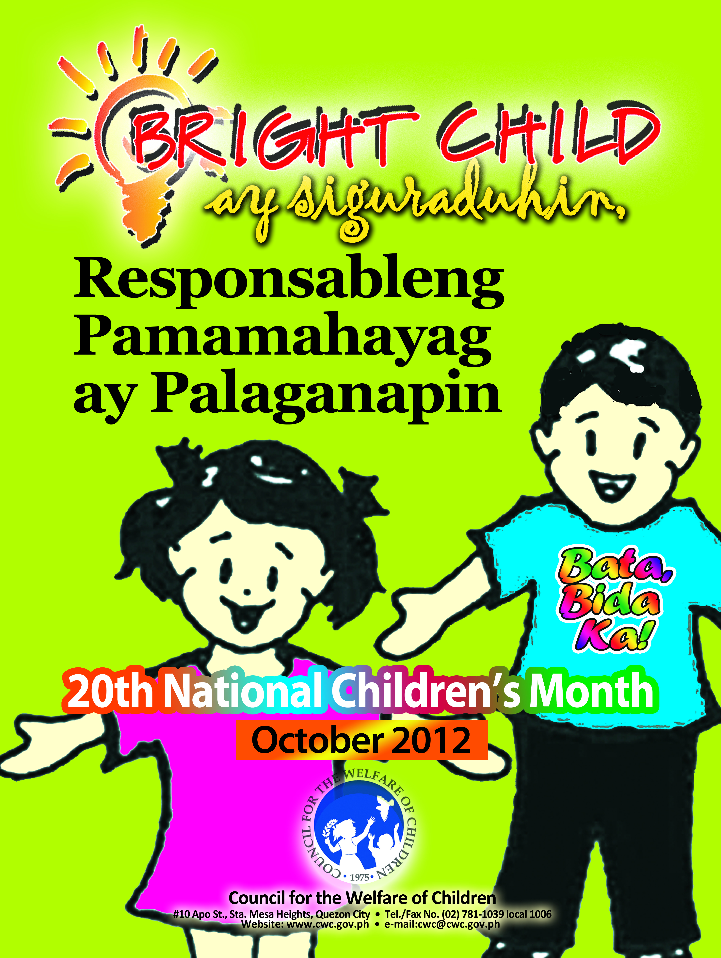

**AgencyLogo**

(Name of Agency)

joins the

**COUNCIL FOR THE WELFARE OF CHILDREN**

**In celebrating the**

National Children’s Month

October 2012

**4 ft.**

**8 ft.**