Republic of the Philippines

DEPARTMENT OF EDUCATION
Cordillera Administrative Region
DIVISION OF BAGUIO CITY

CARAA 2013
APAYAO – Feb. 27-March 3, 2013

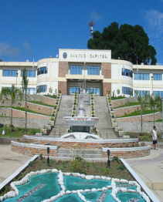

_____________________________________
ATHLETE

FERNANDO B. ELEPONGA, Ed. D.
EPS-I – MSEP/MAPEH

ESTELA LEON-CARIÑO
Schools Division Superintendent

Republic of the Philippines
DEPARTMENT OF EDUCATION
Cordillera Administrative Region
DIVISION OF BAGUIO CITY

CARAA 2013
APAYAO – Feb. 27-March 3, 2013

_____________________________________
TRAINER / ATHLETIC MANAGER

FERNANDO B. ELEPONGA, Ed. D.
EPS-I – MSEP/MAPEH

ESTELA LEON-CARIÑO
Schools Division Superintendent

Republic of the Philippines

DEPARTMENT OF EDUCATION
Cordillera Administrative Region
DIVISION OF BAGUIO CITY

CARAA 2013
APAYAO – Feb. 27-March 3, 2013

_____________________________________
COACH/CO-COACH

FERNANDO B. ELEPONGA, Ed. D.
EPS-I – MSEP/MAPEH

ESTELA LEON-CARIÑO
Schools Division Superintendent

Republic of the Philippines
DEPARTMENT OF EDUCATION
Cordillera Administrative Region
DIVISION OF BAGUIO CITY

CARAA 2013
APAYAO – Feb. 27-March 3, 2013

_____________________________________
DEPED / LGU OFFICIAL

FERNANDO B. ELEPONGA, Ed. D.
EPS-I – MSEP/MAPEH

ESTELA LEON-CARIÑO
Schools Division Superintendent

