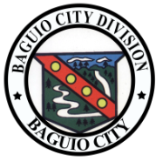Republic of the Philippines
Department of Education
Region I
Division of City Schools
San Carlos City Division
NAME OF SCH...

Department of Education

Cordillera Administrative Region

Division of Baguio City

Military Cut-off , Baguio City

****Republic of the Philippines
Department of Education
Region I
Division of City Schools
San Carlos City Division
NAME OF SCH...

Department of Education

Cordillera Administrative Region

Division of Baguio City

Military Cut-off ,Baguio City