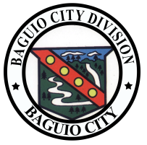
Republic of the Philippines
Department of Education
Cordillera Administrative Region
BAGUIO CITY SCHOOLS DIVISION OFFICE
*82 Military Cut-off, Baguio City 2600
Tel.no.(074) 446-14-88/ (074) 446-67-38

MONITORING TOOL FOR PROGRESS AND OUTCOMES OF PROGRAMS AND PROJECTS SUPPORTED BY STAKEHOLDERS
 | Name of School
 | District
 | Address
A. | Activity/ Intervention:  (indicate the name of your activity/ intervention here)
B. | Date Conducted (duration):
C. | Stakeholder Group/s:
D. | Internal/ External:
E. | Population of targeted Stakeholders in the School: ( Indicate the total Number of pupils and teachers in your school)
F. | Number Reached: (How many did you reached through this activities:  __________________________________________________________________________________________
G. | Media/ Channel: (how did you reach them? E.g: forum, dialogue, facebook group)
H. | Extent of Partners engaged: (indicate the number of partners who committed to the program/ data on investment/ actual number participated)
I. | Feedback: (provide a summary of your post activity evaluations by your partners)-during the activity
J. | Progress (Indicate the school development within the period of activity)- after the activity
K. | Outcomes (indicate the result of the activity)-after the activity
 | *You may write your responses at the back if needed.
 | Prepared by: |  |  | Noted by:
 | School Partnership Coordinator |  |  |  | School Head

*Please attach some pictures
* One form per project

