 | GENERAL QUALITY FORM |  | Document Code: TLF-OSDS  Revision: 00  Effectivity date: 08-20-2018
 | MEMORANDUM |  | Name of Office:  OSDS- Personnel

GENERAL GUIDELINE ON FILLING
(relative to Division Memorandum , s. 2020)

I. STATEMENT OF ASSETS, LIABILITIES, AND NETWORTH (SALN)

1. Download the enclosed 2015 SALN Form at www.depedpines.com or csc.gov.ph

2. Tick box for the type of filing
2.1. FOR JOINT FILING: Declarant MUST provide a copy of his/ her SALN to co-declarant/
spouse
2.2. FOR SEPARATE FILING: Separate application from his/ her spouse
2.3. NOT APPLICABLE: For single/ unmarried declarant

3. Accomplish details. Write “N/A” per blank if not applicable
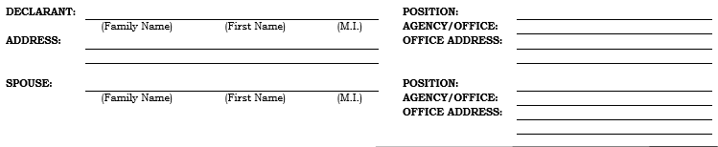

4. Accomplish details. List only name of children below 18y/o. Write “N/A” per blank if not applicable.
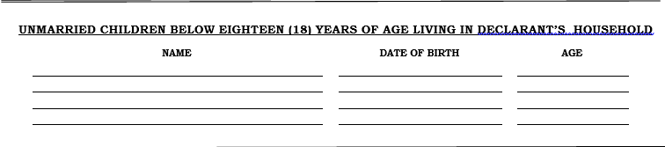
5. Fill in your ASSETS
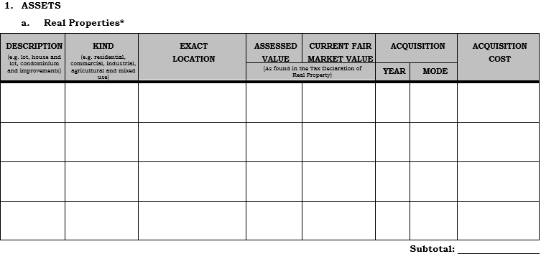

5.1. Real properties shall be accompanied by a description of its kind, exact location, acquisition mode and year, assessed value, far market, acquisition cost of land/ building/ house, including improvement thereon.
5.2. For computation purposes of real properties, ACQUISITION COST shall be used. (A)

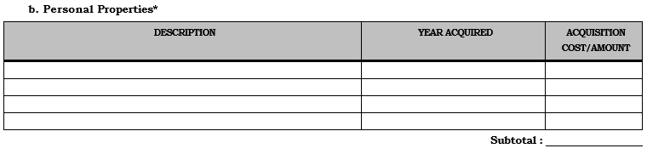
5.3. Assets, such as cash on hand in bank, as well as stocks and the like, denominated in foreign
currency shall be converted into the corresponding Philippine currency equivalent, at the rate of
exchange prevailing as of December 31 of the preceding calendar year. (B)

6. Liabilities
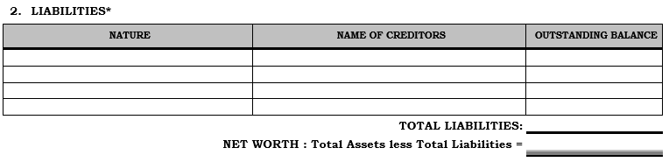
6.1. Under liabilities, nature of liability and name of creditors shall be indicated.
6.2. All existing liabilities, secured or unsecured, whether or not incurred in trade or business,
shall disclose the outstanding balance as of December 31 of the preceding calendar year.
6.3. The declarant’s total net worth, and that of his/her spouse, in case of joint filing, shall be the
difference between the total assets (real and personal properties) and the total liabilities.

7. Business interests and financial connections
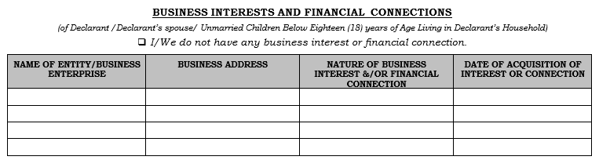
7.1. The declarant, including his/her spouse and unmarried children below eighteen (18) years of age living in declarant’s household, shall declare their existing or connection in any business enterprise or entity, aside from income from government. They shall also indicate the business address, nature of business interest and/or financial connection, and date of acquisition of interest or connection.
7.2. In case there are no existing business interests and financial connections in any business enterprise or entity, declarant shall tick the box provided for.

8. Relatives in the government service
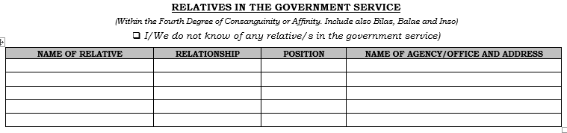
8.1. In case of joint filing, the declarant and his/her spouse shall disclose their relatives in the government within the fourth civil degree of relationship, either by consanguinity or affinity. They shall also state their relationship with the relative, relative’s position in the government, as well as the office name and address.
8.2. In case the declarant and his/her spouse, for joint filing, do not know of any relative/s in the government, they shall tick the box provided for.

9. Certification clause
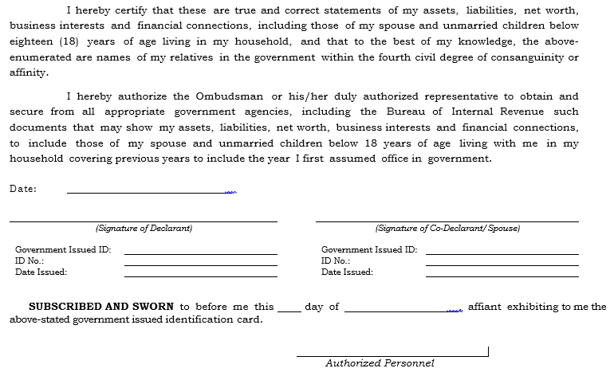
9.1. Affix the date of accomplishment of SALN and other details of the declarant.
9.2. In case of separate filing, only the declarant shall sign in the space provided for, while the
declarant’s spouse shall sign in the space below.
9.3. In case of joint filing, the declarant and his/her spouse shall sign in the spaces provided for
just below the certification.
9.4. Authorized Personnel Administering Oath - follow accordingly:
SALN of TEACHERS & NON-TEACHING – to be signed by PRINCIPAL
SALN of PRINCIPALS – to be signed by SDO ADMIN OFFICER V
SALN of SCHOOLS WITH TIC & HEAD TEACHERS – to be signed by SDO
ADMIN OFFICER V
SALN with JOINT FILLING APPLICATION – DECLARANT’S PRINCIPAL shall
sign and FURNISH co-declarant school

10. SPECIAL INSTRUCTIONS

10.1. Mode of Accomplishing - can be Hand-written, Type-written, or Computerized
10.2. During Accomplishment
10.2.1. For Hand and Type-written – No correction tape/ superimposition
10.2.1. For Hand-written – write legibly and used BLACK-INKED pen
10.3. During Printing
10.3.1. Printing in LONG BOND PAPER (8.5”x13”)
10.3.2. Print BACK-to-BACK
10.3.3. When using additional page, print it on a separate paper
10.3.4. Page 1 should end at TOTAL ASSETS (A+B) – Do not delete rows
10.4. Submission
10.4.1. Be guided by the Schedule of Submission (refer to Annex 1)
10.4.2. Compile SALN in ALPHABETICAL ARRANGEMENT (Lastname basis)
10.4.3. Arrangement during submission is as follows
A. Certificate of Compliance – should be 100% compliance per school
- in case on leave, personnel still MUST submit
B. Transmittal Letter – arrange ALPHABETICALLY (Lastname basis)
- input personnel details (Salary Grade & Position) as of DECEMBER 31, 2019
- input TIN and Networth (refer to individual SALN)
C. Submit in 3 separate folders with label:
School Copy – serves as Receiving Copy
Personal Copy – for employee’s copy
Ombudsman Copy – to be submitted to the Office of the Ombudsman
10.4.4. School Head will be notified accordingly for SALN-related concerns
10.4.5. Submit SOFT COPY (excel format) of the Transmittal Letter to
bgodivision.personnel@gmail.com with Subject Header: SALN 2019 (school name)

I. CERTIFICATE OF COMPENSATION PAYMENT/ TAX WITHHELD (BIR Form 2316)

1. Employee will receive 3 PRINTED COPIES of the form.

2. Counter check your Tax Identification Number (TIN). Write down or correct data if necessary.

3. Employee must input details using a BLACK-INKED PEN item Nos. 6 – 11. Write “N/A” for not applicable items.

4. For personnel who have Tax Payables (refer to BIR Form 2316: Item 29 less Item 31), kindly visit BIR together and present your BIR Form 2316 for settlement of dues.

5. Affix your signature at item 57 and the date of accomplishment. With your 2020 Community Tax Certificate, input the following details to BIR Form 2316:

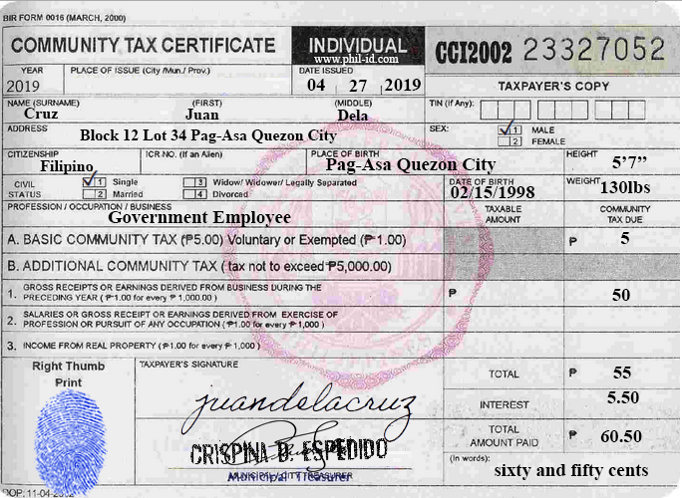
Place of CTC was issued
Date CTC was issued
Total amount paid
CTC No. of the Employee

6. Submit only 2nd and 3rd copy of BIR Form 2316 in 2 separate folders. Arrange ALPHABETICALLY (Lastname basis):
1st copy – Personal Copy
2nd copy – School Copy
3rd copy – to be submitted to BIR

7. Use the ITR Certification as the cover page of your folder. Submit also SOFT COPY (excel format) of the said Certification to bgodivision.personnel@gmail.com with Subject Header: ITR 2019 (school name).

8. Deadline of submission of the 3rd copy is on February 26, 2020.

