Office of the Schools Division Superintendent

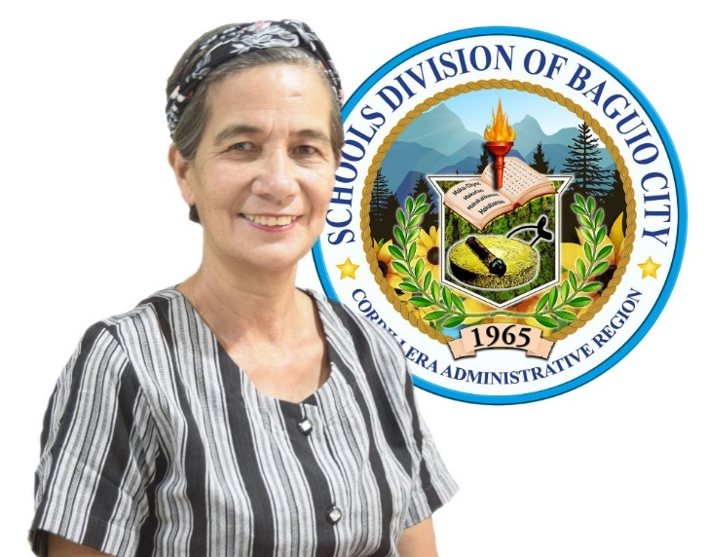
Graduation Message

My felicitations to our ____________ (Elementary, High School, and ALS) Batch 2021 graduates and completers of <STATE THE NAME OF YOUR SCHOOL HERE>

This notable event marks another milestone in your educational ladder as young and promising builders of our nation. Though this school year 2020-2021 has been a struggle, you have consistently become proactive in your tasks to be part of the moving up or graduating class. This persistence equipped you with the competencies needed to survive in this world characterized by volatility, uncertainty, complexity, and ambiguity, the VUCA world.

This year’s achievement with the graduation theme, “Strengthening the Quality of Education Amid the Covid-19 Pandemic” is another affirmation of a completed mission of the department which is to ensure an enabling and supportive environment for effective learning to happen. Thank you, dear learners, co-teachers and support staff, parents, partners, and all those who helped each reach this far.

As you receive your diplomas and certificates, always keep the virtue of gratitude to the people behind your achievements, who were with you as you journey to where you are now. Your parents, siblings, and guardians, who have provided your fundamental needs and to add, guided you to be lifelong learners and responsible enough, which helped you a lot to strive more to explore and improve your study habits.

Your alma mater, mentors, and school administrators, who have nourished and quenched your thirst for learning in the portals of the school and via online modes and other learning modalities. Your friends who have made every step easier and worth treading. Their immeasurable concern for you tied with your fiery desire to be someone worthy in the future has brought you to this significant moment of your lives.

In the pursuit of your dreams, be guided by the wise words of the profound and famous Philosopher Confucius when he said, “The will to win, the desire to succeed, and the urge to reach your full potential, these are the keys that will unlock the door to personal excellence.”

All through the years, you have been making choices with the goal to have a contribution to the communities, our country, and globally as a whole. One prayer from your Schools Division Superintendent is the realization of your dreams, continuing to any of the following: tertiary education, middle-level skills development, employment, or entrepreneurship.

Whichever you choose, this would make your lives more comfortable, develop your full potential as being responsible and helpful, like when you will have the opportunity to help anybody in any way you can today and in the future, then go and do not think twice. As you do these things, using your gifts, talents, and opportunities and with many more good deeds, I believe, our Dear Lord blesses you more, strengthens, and guides you all throughout the challenges that come your way.

Congratulations to Batch 2021!

Congratulations parents and school staff!

On ditediteng ketedjun emin!

Mabuhay!
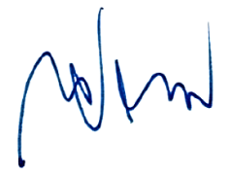

MARIE CAROLYN B. VERANO, CESO V
Schools Division Superintendent

